Epsom & Ewell
16
v
Ash United
Saturday, 12th January 2019 – 3.00 p.m.
Good afternoon and belated Happy New Year to you all! We now enter our 101st year of existence and welcome the players, supporters and officials of Ash United to High Road for an important League match. We secured a fairly comfortable 2-1 win there in November and need to come away with a similar positive result if we are to keep up with the top clubs.

We were last here two weeks ago when we hosted Eversley & California and we gained revenge for our November defeat with a 1-0 win that was more straightforward than the scoreline looked. Bobby Bennett scored our goal but we could have had many more on the day.

Then last week we visited Cove and after a wobbly first half and no protection from the match officials, we turned around a half time deficit to win 2-1 with possibly the goal of the season from Rob Hendry to win the match.

We were to have hosted Godalming Town in the League Cup on Tuesday but this match has now been moved back to Tuesday 12th February for a Chipstead County Cup tie. As a result our next match is on Saturday when we welcome Bagshot for the second time this season, having edged past them in the League Cup back in September.

Please also note that our Division One Cup Quarter Final at Bedfont & Feltham will no longer be played on 22nd January as they have a County Cup tie. We will go there fourteen days later on 5th February instead, not 29th January as previously advised.

The latest update to the promotion situation is available in today’s programme along with many other articles. If you would like to write in the programme or would like to see something specific, just ask me!

We thank long serving supporters Gary and Gemma Jarman for today’s sponsorship. Of course, “Team Jarman” are much more than just supporters. We have many other matches and players available for sponsorship, just ask a Committee member for details.

Enjoy the game!

Rich

You can follow us on Facebook: www.facebook.com/epsomandewellfc
Twitter: @EEFCOfficial Instagram at: www.instagram.com/epsomandewellfc
and Youtube at: www.youtube.com/channel/UCtLrpS0x5OaYUACRT34_zng

Cover photo by Gemma Jarman

Bobby Bennett scores our winner against Eversley & California with Germaine Jeannoel waiting to take advantage in case Bennett’s shot had been saved.

Cherry Red Records Combined Counties League
Division One Table 2018/19
inc Saturday 5th January 2019 | P | W | D | L | F | A | Pts | GD | H | A

Frimley Green | 21 | 14 | 5 | 2 | 42 | 26 | 47 | +16 | 3-0 | 23/2
Bedfont & Feltham | 19 | 14 | 4 | 1 | 65 | 21 | 46 | +44 | 4-4 | 13/4
Epsom & Ewell | 21 | 13 | 2 | 6 | 50 | 34 | 41 | +16 | X | X
Sheerwater | 20 | 12 | 4 | 4 | 46 | 28 | 40 | +18 | 2-3 | ???
Farnham Town | 17 | 11 | 4 | 2 | 42 | 13 | 37 | +29 | 2/2 | 1-4
Tooting Bec | 20 | 11 | 4 | 5 | 43 | 25 | 37 | +18 | 3-1 | 30/3
Ash United | 21 | 10 | 4 | 7 | 53 | 44 | 34 | +9 | 12/1 | 2-1
Dorking Wanderers Res | 23 | 10 | 4 | 9 | 52 | 51 | 34 | +1 | 3-0 | 3-5
Sandhurst Town | 18 | 10 | 3 | 5 | 30 | 29 | 30 | +1 | 20/4 | 2-0
British Airways | 20 | 8 | 4 | 8 | 44 | 44 | 28 | 0 | 16/2 | 2-3
Chessington & Hook Utd | 19 | 8 | 3 | 8 | 35 | 37 | 27 | -2 | 1-2 | 4-1
Godalming Town | 19 | 6 | 3 | 10 | 28 | 39 | 21 | -11 | 3-2 | 26/1
Bagshot | 23 | 6 | 3 | 14 | 27 | 68 | 21 | -41 | 19/1 | 3-0
Eversley & California | 18 | 5 | 1 | 12 | 33 | 44 | 16 | -11 | 1-0 | 1-2
Kensington Borough | 20 | 3 | 4 | 13 | 26 | 55 | 13 | -29 | 1-1 | 9/3
FC Deportivo Galicia | 19 | 3 | 3 | 13 | 28 | 38 | 12 | -10 | 12/3 | 3-0
Fleet Spurs | 20 | 4 | 0 | 16 | 33 | 58 | 12 | -25 | 6/4 | 3-2
Cove | 18 | 2 | 1 | 15 | 19 | 42 | 7 | -23 | 3-2 | 2-1

AC London (removed) | 15 | 9 | 2 | 4 | 36 | 25 | 29 | +11 | - | 6-0

Lucky Day? – 12th January
Played 13 - Won 7 Drawn 2 Lost 4 - For 26 Against 20 - PPG 1.77 - Good
Our Club record against Ash United
Played 20 - Won 11 Drawn 3 Lost 6 - For 50 Against 32 - PPG 1.80 - Good
Our Largest wins and losses against Ash United
24th January 1981 - W 6-0 - Surrey Senior Cup (A)
27th October 2009 - L 1-4 - Combined Counties League Premier Division (A)
Ash United‘s last visit
22nd March 2014 - Won 3-0 - Combined Counties League Premier Division

Simon Funnell
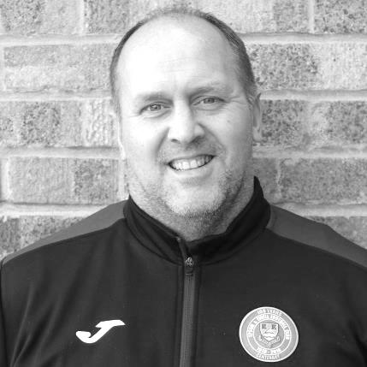
Good afternoon to you all and welcome to our visitors from Ash United.

Today I’m hoping we can continue our good recent form. I have been delighted with how things have been going lately whether it’s a win playing well or a win playing not so well we will take every point we can get.

The aim for rest of the season is to win as many games as possible and see where it takes us.

On the player front we have lost Theo Campbell due to the distance he had to travel and he wanted something closer to home, so we wish him well. Also David Jones has decided to go travelling so probably won’t be around until next season.

On the injury front Taryn Smith s getting closer to returning to training. We have one new player with us in Ben Chick, Ben has played for me before at East Grinstead Town and then moved onto Bognor Regis until he had a knee injury which has kept him out the game for three or so years. We will look to ease Ben in over the rest of the season.

There maybe one other signing in the next week or so which will make the squad very competitive and provide good competition for places.

I’m also very pleased to have a proper physio on the touchline now and welcome Chantelle Farrell to the club.

Enjoy the game!

Simon

Recent Results and Fixtures
Combined Counties League – Saturday 29th December
Ash United | 0-3 | Farnham Town
Epsom & Ewell | 1-0 | Eversley & California
Fleet Spurs | 1-2 | Godalming Town
Kensington Borough | 1-1 | Dorking Wanderers Reserves
Sandhurst Town | 2-0 | Cove
Sheerwater | 0-0 | Chessington & Hook United
Combined Counties League – Saturday 5th January 2019
Bedfont & Feltham | 3-2 | Sheerwater
Chessington & Hook United | 1-3 | Frimley Green
Cove | 1-2 | Epsom & Ewell
Eversley & California | 0-3 | Tooting Bec
Farnham Town | 6-0 | Kensington Borough
FC Deportivo Galicia | 1-3 | Ash United
Godalming Town | 2-0 | Bagshot
Combined Counties League – Saturday 12th January 2019
Bagshot | V | Bedfont & Feltham
British Airways | V | Farnham Town
Cove | V | Fleet Spurs
Dorking Wanderers Reserves | V | Eversley & California
Epsom & Ewell | V | Ash United
Frimley Green | V | Sandhurst Town
Sheerwater | V | Godalming Town
Tooting Bec | V | Chessington & Hook United
Combined Counties League Cup Third Round – Tuesday 15th January 2019
AFC Hayes | V | Bedfont & Feltham
Chertsey Town | V | Abbey Rangers
Knaphill | V | Fleet Spurs
Sheerwater | V | Banstead Athletic
Spelthorne Sports | V | Hanworth Villa
Combined Counties League Cup Third Round – Wednesday 16th January 2019
FC Deportivo Galicia | V | Sutton Common Rovers
Guildford City | V | CB Hounslow United
Combined Counties League – Saturday 19th January 2019
Bedfont & Feltham | V | Fleet Spurs
Chessington & Hook United | V | Kensington Borough
Epsom & Ewell | V | Bagshot
Eversley & California | V | Cove
Farnham Town | V | Dorking Wanderers Reserves
FC Deportivo Galicia | V | Sandhurst Town
Sheerwater | V | Frimley Green

Surrey Premier Cup
First Round
Carshalton Athletic U19 | w/o Ash | Ash United
Shene Old Grammarians | 2-4 | Old Wilsonians
Lingfield | 5-1 | Horley Town Reserves
Alfold | 2-0 | Godalming Town
Epsom & Ewell | 5-0 | Knaphill U23
Reigatians | 0-4 | Frimley Green
Met Police Reserves | 3-3 | FC Deportivo Galicia
Met Police Reserves win 5-4 on penalties
Second Round
Ash United | 3-1 | Chessington & Hook United
Alfold | 0-1 | Nottsborough (holders)
Old Wilsonians | 1-6 | Lingfield
Sheerwater | 5-0 | Corinthian Casuals Reserves
Farnham Town | 4-1 | Westfield Reserves
Epsom & Ewell | 4-0 | Dorkinian
Met Police Reserves | V | Dorking Wanderers Reserves
Bagshot | V | Frimley Green
Quarter-Finals
Ash United | V | Bagshot / Frimley Green
Met Police Res / Dorking W Res | V | Epsom & Ewell
Farnham Town | V | Lingfield
Nottsborough (holders) | V | Sheerwater

Esoteric League Division One Challenge Cup
First Round
Farnham Town | 0-1 | Godalming Town
Cove | 2-1 | British Airways
FC Deportivo Galicia | 2-1 | AC London
Second Round
Eversley & California | 2-3 | Bedfont & Feltham
Epsom & Ewell | 1-0 | Sandhurst Town
Tooting Bec | 4-1 | Ash United
Kensington Borough | 0-2 | FC Deportivo Galicia
Sheerwater | 2-3 | Chessington & Hook United
Fleet Spurs | 0-0 - 4-3p | Cove
Dorking Wanderers | 1-2 | Frimley Green
Godalming Town | 6-0 | Bagshot
Quarter-Finals
Tooting Bec | 22/1 | Frimley Green
Bedfont & Feltham | 5/2 | Epsom & Ewell
FC Deportivo Galicia | 22/1 | Godalming Town
Fleet Spurs | 26/1 | Chessington & Hook United

From behind the goal
Epsom & Ewell 4-4 Bedfont & Feltham
Combined Counties League - Division One - Saturday 8th December 2018

Salts denied at the last in eight goal thriller

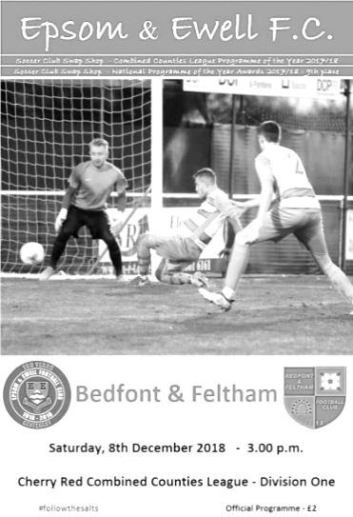
As the wind and the rain swept across High Road in torrents, the two teams produced a superb advert for attacking football in difficult conditions. Unfortunately though we were unable to secure the win we required to close the gap on title favourites Bedfont & Feltham who came from behind on three occasions to secure a point.

It could be argued that the visitors deserved a point for their resilience, but a few key decisions went against us in this match and a number of chances went begging. Without doubt this match was there for the taking which makes the result; our first 4-4 draw since 2014 and only the ninth in club history, that bit harder to take.

Going into this match we already knew we were without the suspended trio of Steve Betancourt, Reisse Griffin and Captain Scott Murphy, while Elliott Thompson and Olly Martinez were also unavailable. Luke Elgar returned to the line-up and played on the left side of defence to accommodate new arrival Louis Chin, while another debutant was Hakim Griffiths up front and he played alongside the returning Rob Hendry. Finally, Jamie Watts came back in at the back after missing the win over Godalming Town the previous Saturday.

We started brightly, although the first opportunity went to the visitors when Ross Nunn saw Conor Young tip his shot over the bar. We responded well and Rob Hendry latched on to a deep cross and his shot from twelve yards was equally well turned over by David Windmill. Then Liam Roberts reached the touchline on the left, cut back inside and fired at goal with Windmill blocking the shot and the danger was cleared. This was all in the opening ten minutes but the visitors went ahead in the eleventh when a pass inside Chin was latched onto by Reece Gairy who slid the ball under the advancing Young to open the scoring.

The lead lasted less than a minute as Elgar advanced on the left and curled a deep cross over for Hendry to dispatch with a good header that gave the keeper no chance. We should have taken the lead in the 18th minute when Roberts beat his man to the touch line but was then elbowed in the neck in the penalty area by Ash Hitchinson. As the referee ran over with a yellow card in his hand I was thinking that it was the wrong card and should have been a red one for the challenge, but to my complete astonishment he hadn't even given the penalty and booked Roberts for diving! Now we have had a lot of penalties this season and a couple may have been soft, but this decision was right up there with the worst of the season. As it turned out we would lead a minute later anyway after Hendry got down the left and cut back for Bobby Bennett to fire home from eight yards!

Lloyd Connelly nearly made it 3-1 as an Adam Heagney free kick was flicked on by Elgar to the far post, but he couldn't get a solid boot on the ball and Griffiths was just wide with another attempt before a Bennett cross just eluded the diving Hendry. Despite all of these chances we couldn't extend the lead and in the 38th minute Michael Capon collected a ball played inside our other full

back and crossed from the right. The delivery was nearly cut out but not quite and Kelvin Karanja forced the loose ball in from close range for the equaliser.

There was still time for more controversy as a nasty, studs up challenge on Hendry out on the touchline only earned Charlie Dunckley a yellow card. This inconsistency would come back to hurt us later in the match. From the free kick we attacked again and Elgar set up Hendry who fired a cross field ball to Bennett in a superb position but his touch let him down at the crucial moment and he was forced too far wide as Windmill cut out his low cross.

With four goals in the first half, the second half opened up in a similar manner as we went back in front in the 47th minute. A Chin throw on in the attacking corner was sliced away by a Bedfont defender and the ball skewed away across the penalty area to Roberts at the far post on the left. He sold his defender completely and rolled the ball past Windmill from close range for our third goal.

The visitors responded with a low shot from the right that Young saved but was unable to hold on to and a bit of a scramble followed, during which Watts picked up an injury as the ball was cleared. Fortunately he was able to continue after treatment. Meanwhile at the other end Hendry and Griffiths were beginning to show signs of linking up well and Hendry was set up for another shot but it was rushed and went straight at Windmill. Then Roberts did well on the left before laying the ball back to Heagney whose delivery was headed wide by Hendry from close range. Luckily, the offside flag spared his blushes. Hendo was then unfortunate in the 65th minute after Griffiths found him wide out and his angled drive from twenty yards clipped the crossbar and went out for a goal kick.

The missed chances came back to haunt us in the 67th minute as Farhad Mahboudi collected the ball before beating a couple of half hearted challenges and driving the ball past Young into the corner to level the match once again. However, two minutes later we were back in front as Griffiths robbed a defender on the edge of the area, then beat another with his right foot before drilling the ball across Windmill into the bottom corner for a quality finish. Surely we could hold on now?

We continued to press for a fifth goal and a deep cross from Heagney was headed back to Bennett by Hendry but the shot was just wide of the post. However, the dynamic of the game was changed once again by another contentious decision as Jamie Watts went in for a challenge not too far outside our penalty area and was sent off. He was stretching a little but this looked very harsh from where I was and especially so with the memory of the first half foul on Hendry which only picked up the yellow card, which left supporters wondering about the consistency of the decisions. It left us on the back foot for the remaining eleven minutes and we had to withdraw Griffiths with Todd Murphy coming on at the back.

The visitors continued to push as they fought to avoid what would have been only their second league defeat of the season and Karanja broke through on goal in the 87th minute, but Young stood his ground and the shot was spooned onto the bar with the ball falling back to our keeper. However, we wouldn't be so fortunate in the 90th minute when a ball out to the right in space left Young in two minds as to whether to go for the ball. He realised he wouldn't get there and retreated but Mahboudi clipped the ball over him into the net from the angle to level the scores at 4-4. Seven minutes of injury time followed, during which we also lost Roberts with what appeared to be a damaged hamstring. It is hoped that the injury is not too serious and fortunately we have two weeks now before our next match which may help. Regrettably that break will not help the suspension situation and we do seem to be on the rough end of some decisions right now, with three in particular in this match that denied us from claiming the win we deserved on the day.

Epsom and Ewell: Conor Young, Louis Chin, Luke Elgar, Adam Heagney (c), Jamie Watts,
Lloyd Connelly, Bobby Bennett, Ryan Sullivan, Hakim Griffiths, Rob Hendry, Liam Roberts

Subs: Todd Murphy for Griffiths (80), Germaine Jeannoel for Hendry (89),
Joshua Caulcrick for Roberts (97)

From behind the goal
Epsom & Ewell 1-0 Eversley & California
Combined Counties League - Division One - Saturday 29th December 2018

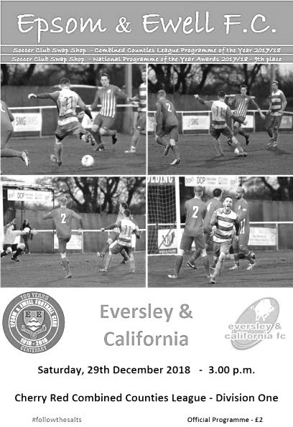
Salts finally break through the Eversley resistance

Our boys produced a high tempo performance from start to finish to dominate virtually the whole match against a willing and committed but ultimately limited Eversley & California side at High Road on Saturday. However, in the end it required a slightly fortunate goal for us to clinch the three points after a number of chances had gone begging.

We were missing a number of players this day. Captain Scott Murphy was away with his family and Liam Roberts was working. Other absentees included Reisse Griffin, Hakim Griffiths and Roy Gayle, while Jamie Watts finally started a three match suspension for his sending off at Bedfont & Feltham in our last outing three weeks previously. No doubt the visitors were missing a number of players too, most notably their winger Mo Davies who was on holiday. This was good news as he had given us a lot of trouble back in the earlier meeting at Fox Lane on 24th November when we were deservedly defeated by two goals to one. In fact, it is a measure of our progress that this remains our only defeat in twelve matches since 20th October and that fine sequence was extended in this match.

In goal Conor Young made his 50th appearance for our club and was rewarded with the Captaincy for this match. His defence also gave him the present of having one of the quietest days he has had since joining our club as the back four of Louis Chin, Luke Elgar, Adam Heagney and Lloyd Connelly mopped almost everything up and left two goal hero from the previous meeting Brad Brown with hardly an opportunity in the match.

At the other end Charlie Lusty in the Eversley goal had a much busier day than Young, although it could have been busier still had we hit the target more often. Instead, the story of much of the match was a succession of chances that went either high or wide with the few that were on target being mostly blocked by committed visiting Captain Connor Allston. The exception to this occurred in the second minute when an awkwardly bouncing ball fell kindly for Rob Hendry who avoided a high challenge only to see his powerful low drive tipped around the post for a corner from 15 yards by Lusty.

Olly Martinez, playing a full ninety minutes despite a long overnight flight, was next to show on the seventh minute when his low ball in from the wing came back off the outside of the post before Bobby Bennett chose to shoot from a narrow angle but could only find the side netting. Hendry put a header wide but redeemed himself with a twenty yarder that Lusty did well to hold with Germaine Jeannoel in a perfect position to deal with any fumble and it was

then Jeannoel, making a rare start, that did well on the left wing before pulling the ball back beyond Hendry to Bennett whose shot was well blocked by Allston. As the half closed Connelly did well at the far post to deliver a deep cross to the opposite post where Hendry did brilliantly to knock the ball back in just inches ahead of the advancing Luke Elgar. As the players went off at half time it looked just a matter of time before we would break through.

In our previous twenty-eight matches this season only Step Five Beckenham Town have prevented us from scoring, so confidence was high amongst supporters, but as the minutes ticked away would we panic? Concern then followed when Jeannoel was kicked in the chest by Allston only for the referee to decide to stop the match during our attack so that their man could receive treatment!

Moments later from a rare attack Elgar made a good saving challenge just as it looked as though Eversley may break through, but we were soon on the attack again and Bennett blazed high and wide from an angle with frustrated teammates waiting for a cross. Bennett redeemed himself in the 59th minute in slightly unusual circumstances as he reached a good crossfield ball and drilled his shot across goal into the far corner. At least, that's what I'm sure he tried to do, but what actually happened was that he scuffed the ball slightly and hit it into the ground, taking much of the pace off the shot which deceived the otherwise excellent Lusty and headed towards the far corner.

Even more unusually, and in a repeat of what I thought was a once in a lifetime event, the ball then hit the supporting stanchion inside the goal and bounced back out, as had been the case just four weeks previously when Scott Murphy scored our winning goal against Godalming Town. The goal was in the same net, but it was the opposite stanchion! It's hard to imagine what was going through the head of the person that designed these goals, but that aside it is astonishing that such a rare occurrence could happen so soon after the previous one!

Ben Chick came on for his debut in relief of Jeannoel with Martinez moving to the right and Bennett playing more centrally. However, we continued to waste chances with Heagney and Hendry putting headers high and wide respectively from well placed Bennett corners. Hendry then volleyed a half cleared Heagney free kick over the bar before Chick also struck his shot over the bar from a good position.

We nearly scored a second goal in really bizarre circumstances when Bennett again shot at goal from a wide angle, but the ball took a massive hop as it bounced in front of Lusty who did really well to claw the ball away at the last second. Our final chance came in injury time as Martinez cut in from the right and sent a shot just wide of the far post from fifteen yards, while the visitors just had time to produce their third foul throw of the match. It was that sort of day for the visitors!

From our point of view though, we are looking very strong. We are making a number of chances right now and if there is a criticism, it is that we are not putting enough of these away at the moment. It won't be long, but at some point in the near future I am sure that we will have a day when they all go in. That should be worth seeing!

Epsom and Ewell: Conor Young (c), Louis Chin, Luke Elgar, Ryan Sullivan,
Adam Heagney, Lloyd Connelly, Bobby Bennett, Elliott Thompson, Rob Hendry, Germaine Jeannoel, Olly Martinez

Subs: Ben Chick for Jeannoel (60)

From behind the goal
Cove 1-2 Epsom & Ewell
Combined Counties League - Division One - Saturday 5th January 2019

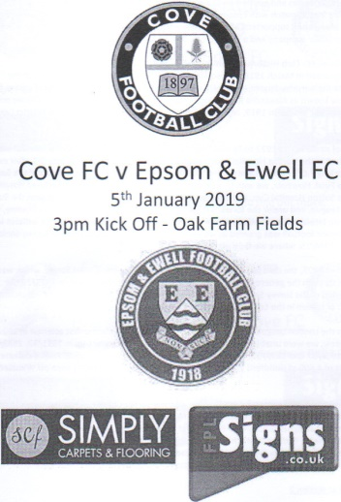
World class Hendry strike wins a bad tempered match

Back in September we had a major scare when Cove came to High Road and led twice before a late winner gave us the points from a 3-2 win. At Oak Farm we had a similar scenario as we had to come from behind again to take the points on an awkward surface against a determined and occasionally over-committed Cove side, with the winning goal from Rob Hendry well worth the admission money on its own.

This game became bad tempered, largely due to a series of baffling decisions by the official whose greatest error was to fail to issue a straight red card to Djanga Tudila for a horrible challenge on Liam Roberts in the 24th minute. By this inaction he gave the green light for the players to take the law into their own hands out there which led to some unpleasant confrontations between the players at times and really spoiled a large part of the match, particularly in the first half. For our players to come through those circumstances and turn the match around in the second half is worthy of much credit.

Liam Roberts, Elliott Thompson and Reisse Griffin returned to the starting line up in place of Olly Martinez, Germaine Jeannoel and Luke Elgar, while Jamie Watts continued his three match suspension. We had a scare as early as the second minute when a long ball was flicked on and the Cove striker saw his shot blocked by Conor Young. In response Louis Chin made a great run, beating players to reach the right hand touch line, but his low cross was cleared away at the last minute. However, with the clock showing the fourteenth minute we were caught out in a similar manner to the earlier opportunity and this time Josh Moody lifted his shot past Young to give the home side an early lead.

We reacted fairly well and Bobby Bennett fired in a low shot that was well blocked by the feet of Aiden Upward in the Cove goal but in the 16th minute a right wing cross left a Cove striker with what looked like an easy finish from close range, but luck was on our side and the ball bounced a bit high for the player who was unable to get a meaningful shot at the grateful Young.

In the 24th minute we had the challenge I referred to earlier. Now, back in September Roberts had won an admittedly soft penalty when he had fallen over Tudila's leg which enabled us to get back into that match. I don't know whether this was still on the defender's mind, but he had already put in a solid challenge on our man before going straight through him on the touchline in a reckless manner. The challenge was very high and extremely dangerous and would probably have earned a red card back in years past. In fact, think Benjamin Massing on Claudio Caniggia in the opening match of the 1990 World Cup (look it up on YouTube, kids!). Despite the referee telling our players to go away and to let him "do his job" he then patently failed to "do his job" by issuing just a yellow card and then spending more time lecturing Elliott Thompson about his totally understandable complaints.

Player safety is often quoted these days, especially when it comes to the much larger number of postponements we get these days, yet our player was fortunate to escape serious injury here and the decision pretty much set the tone for the rest of the match.

Finally, the match restarted and it has to be said we were struggling a little. On a bumpy surface against a team that were making things very difficult for us we nearly conceded again when Lloyd Connelly

overplayed in a dangerous area and lost the ball. Fortunately the shot was weak and Young made a comfortable save. We didn't know it at the time, but this would prove to be the last real chance the home side would have in the match.

We were nearly back on level terms when Hendry nipped in front of Upward to reach a right wing pass and he laid the ball back for a shot that the keeper did well to block, while Bennett's follow up was also denied from close range. It was looking like it wasn't going to be Bennett's day as Upward then scuffed a clearance straight between his legs with our man standing just ten yards from goal! Things then got worse after Captain Scott Murphy injured his calf and had to hobble off with Ben Chick coming on to replace him. This meant that Roberts switched wings away from Tudila with Bennett coming in to play more centrally.

Cove nearly broke away but Ryan Sullivan then took one for the team, deservedly earning a yellow card for his tackle. We pushed for an equaliser only for the first half to end after just two minutes of injury time, despite the trainer being on the field four times and our early substitution. There should have been at least five minutes and maybe even seven played, but we went in at the half under no illusions about the task ahead of us and needing to play better, regardless of the other distractions.

And to our boys credit, we did produce a much improved second half, taking the game to our hosts down the hill. Our equaliser came quickly as we were level in the 50th minute when a Hendry corner cleared the first man and Reisse Griffin met it at the far post with a solid header from eight yards that took a slight deflection off a defender, giving Upward no chance to save it. Two minutes later we were nearly ahead after Roberts cut in from the right. A defender got a toe to the ball to dispossess him, but it went across the goal to Bennett who struck the ball goalwards from six yards out, only to be denied by a superb save from Upward who dived at his feet and deflected the ball over the bar.

Thompson then saw his shot on target blocked by a defender before Chick fired the rebound wide and we were well on top now. There will still concerns from time to time and Chin picked up a booking on the far touchline. However, equally concerning were the decisions and it was unusual to see the Assistant flag for a foul in the middle of the pitch just outside our penalty area, clearly because he felt that the referee had missed the incident. This proved to be pivotal as that decision would in fact lead to the winning goal when a deep delivery was flicked on and as the ball sat up just in front of Hendry some thirty yards out he hooked it on the turn first time, dipping it over Upward and bouncing just before it crossed the goal line for a spectacular goal.

Todd Murphy and Roy Gayle entered the fray for the injured Connelly and the tiring Thompson and we nearly made it three-one when Bennett shot wide on the turn from close range. He then nearly produced a great finish moments later when Roberts broke on the right and squared the ball to him. He clipped it goalwards instantly, but it went less than a yard beyond the far post. The final chances came in injury time as the hosts tired, firstly when Hendry intercepted a poor Upward clearance, but didn't realise how much time he had and rushed his attempt sending the ball flying over the bar. This was followed by two attempts in quick succession from Hendry and Bennett respectively from very narrow angles. Hendry's shot was well blocked by Upward while Bennett sliced his wide after the ball bobbled on him. There will be other days where Bennett scores a hat trick with similar chances, but he has been extremely good this season and all strikers have an unlucky day from time to time.

On this occasion, Epsom had to settle for just the two goals and in the end it was enough to register what is our very first league double fo the season. It is to be hoped that our injured players are ready to go for the visit of Ash United in seven days time and we can be thankful that there were no further injuries, despite a distinct lack of protection out there which is very sad, but totally accurate to report.

Epsom and Ewell: Conor Young, Louis Chin, Reisse Griffin, Elliott Thompson, Adam Heagney, Lloyd Connelly, Bobby Bennett, Scott Murphy, Rob Hendry, Ryan Sullivan, Liam Roberts

Subs: Ben Chick for Murphy (38), Todd Murphy for Connelly (75), Roy Gayle for Thompson (80)

This Day in History - 12th January
Date | Day | Competition |  | Opponents |  | Scorers
12/01/35 | Sat | Amateur Cup 1 | A | Wimbledon | 0-2
12/01/46 | Sat | Friendly | H | Crawley | 5-3 | G.Brogdale (3), K.Holliday, S.Scott
12/01/52 | Sat | Corinthian League | H | Maidenhead United | 3-1 | B.Goddard, V.Honey, C.Banham
12/01/57 | Sat | Corinthian League | A | Chesham United | 5-0 | B.Jenkins (2, 1 pen),J.Bangs (3)
12/01/74 | Sat | Surrey Senior League | H | Chessington Utd | 2-0 | D.Ritman (2)
12/01/80 | Sat | Isthmian League 1 | A | Finchley | 0-0
12/01/81 | Mon | Southern Combination Cup 1 | A | Wokingham Town | 1-2 | A.Venturini
12/01/91 | Sat | Isthmian League 2s | H | Petersfield United | 3-0 | S.Barwick (2), A.Boxall
12/01/99 | Tue | Surrey Senior Cup 2 | A | Woking | 0-5
12/01/02 | Sat | Isthmian League 3 | H | Abingdon Town | 3-1 | M.Freeborough, S.Huckle, B.Stevens
12/01/08 | Sat | Combined Counties Premier Division | A | North Greenford United | 1-1 | K.Hough
12/01/13 | Sat | Combined Counties Premier Division | A | Badshot Lea | 3-2 | N.Ayling, R.Burns (2)
12/01/16 | Tue | Combined Counties League Cup 3 | H | Ashford Town (Mx) | 0-3
Historical Decades
90 years ago – Epsom Town F.C.
05/01/29 | Sat | Friendly | H | Chatham | 4-1 | W.Challis (2), H.Etheridge (pen), F.Watts
80 years ago – Epsom F.C.
14/01/39 | Sat | London League | H | Dagenham Town | 0-1
70 years ago – Epsom F.C.
15/01/49 | Sat | London League | A | Woodford Town | 2-3 | B.Cutter, H.Watkins
60 years ago – Epsom F.C.
10/01/59 | Sat | Corinthian League | H | Eastbourne | 0-0
50 years ago – Epsom & Ewell F.C.
11/01/69 | Sat | Athenian League 2 | A | Uxbridge | 3-2 | A.Parrott, G.Hemphrey, J.McNaught
40 years ago – Epsom & Ewell F.C.
16/01/79 | Tue | Isthmian League 1 | A | Bromley | 0-3
30 years ago – Epsom & Ewell F.C.
11/01/89 | Wed | Isthmian League 2s | A | Horsham | 3-1 | L.Harding, C.Walcott, C.Holding
20 years ago – Epsom & Ewell F.C.
12/01/99 | Tue | Surrey Senior Cup 2 | A | Woking | 0-5
10 years ago – Epsom & Ewell F.C.
13/01/09 | Tue | Combined Counties Premier Division | A | Cove | 2-2 | D.Marvell (2)

History Corner – 12th January
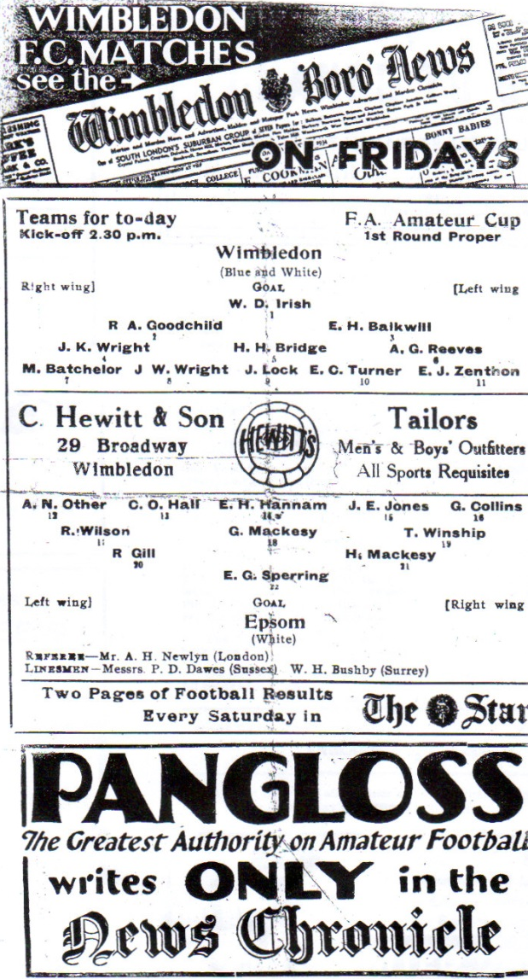
84 years ago today we visited Wimbledon for an Amateur Cup tie, not realising that this would be the final time we would ever reach the First Round Proper. It was the third time we had reached this stage and in 1930/31 we drew the holders Ilford, then in 1931/32 we had to defeat Ipswich Town just to earn a tie at the holders Wycombe Wanderers! This time out we drew another Isthmian giant who would go on to reach the final, losing after a replay to Bishop Auckland. Understandably we were brushed aside 2-0 in front of 5,000 spectators at Plough Lane. (see programme pictured)

73 years ago today we welcomed Crawley to West Street for a friendly, defeating them 5-3. Obviously they are a bit higher up nowadays! Gordon Brogdale was in the process of scoring 44 goals in 32 matches that season and he got another three this day, while Ken Holliday and Stan Scott scored the others.

62 years ago today we made the journey to The Meadow, home then as now of Chesham United and smashed them 5-0 in a Corinthian League match with Johnny Bangs scoring three on his way to 53 goals that year, while Brian Jenkins scored the other two. Bangs’ tally represents the third highest in club history behind Bill Goddard’s 54 and Reg Marlow’s 65.

Peter Norris
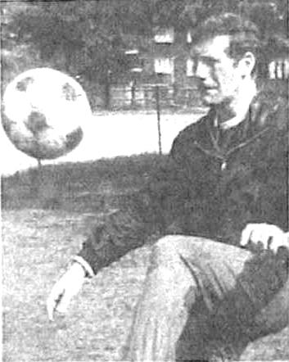
As many of you will be aware by now, we lost a former Manager just before Christmas in Peter Norris at the age of 78.

Many of our supporters will have known about Peter, through time spent at Glyn School where he was a P.E. teacher, or maybe you remember him from his time in Management. Regrettably, I never got to meet him and to find out that he had died recently, and had been living all that time in Ewell Village was doubly sad as he represents a time at our club when there was little coverage. Yes, there were match reports in the excellent local papers, but they never really covered what was actually going on at the club.

As a result, I have very little that I can write about Peter Norris, in fact, only the one photo also, (which is repeated later on in this issue for another reason) but I am nothing if not thorough, and have managed to find out quite a bit about him from a couple of sources, starting with a former Assistant Coach from the early seventies by the name of Mick Matthews.

I joined the year after Pete Norris took over as Manager having played for him at Glyn School and at Surrey under Pete, Dario Gradi and Ted Powell, all of whom made a significant contribution to Coaching in that era. I joined as an Assistant to the Coach at the time Don McBurney.

“Coaching” was just beginning to emerge back then and these three made quite an impact along with others like the future Wales manager Mike Smith, Eddie McCluskey who had much success at Enfield during the seventies with Fred Callaghan, Allan Batsford who would have major success at Walton & Hersham and then Wimbledon, along with others who Manager further up like Lennie Lawrence.

In no way was the job glamorous or indeed how it had been sold to Pete, or for that matter, how he sold it to me! Finances were – shall we say – non-existent so pre-season was spent on ground repairs, burning weeds, decorating the old clubhouse and trying to repaint the old concrete team baths just to have a chance of attracting players as many had left.

The diehards of Colin Bell, Eric Norman, Alan ‘Tommy’ Thompson, Terry Self and Graham Hemphrey (ex-Harrow Borough) stayed. Kenny Ireland and his brother Bobby

were there for a while before Ken went to Sutton, and Pete initially trialled a bunch of other Seniors (most of whom saw the ground and sniffed, particularly Tony Slade from Tooting’s Nottingham Forest side of 1959) and a younger group; Keith Spears, Mick Drake, Graham Petersen, Rich Hook, Jimmy Honeywood, Alan Payne from his Surrey Schools side and Bob Chappell and a couple of others from Glyn Old Boys including Johnny Eales.

In my first year Chris Roots, Mick Jones, Dave Jackson and Andy Fillery came from Croydon/Whyteleafe. Some local lads also trialled, some of my lads from Westways and John Pritchard, Colin Rose, Alan Newton from Epsom Boys Club. Times were tough; we didn’t even get petrol money for away games, some of which involved long journeys, Eastbourne (5 in a mini!) Herne Bay etc. and Pete I recall even paid some important players from his own pocket (only way to get Ken Jolly to turn up).

We tried fundraising discos but the first while successful was then blighted by the newly restocked clubhouse being burgled and all stock being nicked! Pete departed for Redhill soon after. I remained for a while but then joined Pete at Redhill in January 1973. Then in 1973 he went on to Woking.

Another person who remembers him is a good friend of mine Paul Stewart, who was at Glyn School the same time as our Treasurer Steve Dyke and regular supporter Nigel Pond.

Outside of his football management, Pete Norris was the living embodiment of the 1970s school PE teacher. Someone whose teaching style probably mirrored his half-time team talks when results were not going the right way on the field. You either learned to climb a rope, dribble a basketball or perform a backflip over a bench or you found yourself the recipient of the hair-dryer treatment in front of the rest of the class. But there was a consideration for his students that he was going to get them to perform to the best of their abilities in the gym or on the sports field one way or another.

His one lasting legacy from his time at Glyn School came in the late 1970s when word went round the school that another local teaching establishment, Longmead, had challenged any at Glyn supposedly hard enough to meet in the local park next to Epsom's old ground at West Street by coincidence. Pete Norris made the three or four dozen kids milling around scarper on sight when he got out of his legendary TR-7 armed with a cricket bat. That story remains legend amongst Glyn Old Boys to this day.

Although I was no favourite of his during my days at Glyn, I did come across him several years afterwards on the golf course. He was a man who in many ways was larger than life and anyone who knew him will be saddened at his passing.

From looking at a few tributes on Facebook, Pete will clearly be remembered as one who was hard but fair and it is my regret that I never got to find out more for myself.

He passed away in Ewell Village on 9th December 2018, a month short of his 79th birthday after a struggle with MS and the club held a minute’s silence in our previous home match.

Centre page for results

Centre page for results

First Eleven Appearances 2018/19 - (max 30)
Name | Debut | 2018/19 |  |  |  | Career Totals
 |  | App | Sub | Tot | Goals | App | Sub | Tot | Goals
BENNETT Bobby | 12/08/2018 | 24 | 0 | 24 | 17 | 24 | 0 | 24 | 17
BETANCOURT Steve* | 18/08/2018 | 21 | 1 | 22 | 1 | 21 | 1 | 22 | 1
BORRETT Ricky | 04/08/2018 | 9 | 0 | 9 | 0 | 9 | 0 | 9 | 0
CAMPBELL Kieran* | 29/09/2012 | 7 | 3 | 10 | 2 | 59 | 3 | 62 | 2
CAMPBELL Theo* | 28/08/2018 | 2 | 9 | 11 | 1 | 2 | 9 | 11 | 1
CAULCRICK Joshua | 17/02/2018 | 0 | 4 | 4 | 0 | 0 | 5 | 5 | 0
CHICK Ben | 29/12/2018 | 0 | 2 | 2 | 0 | 0 | 2 | 2 | 0
CHIN Louis | 08/12/2018 | 3 | 0 | 3 | 0 | 3 | 0 | 3 | 0
CONNELLY Lloyd | 14/10/2017 | 30 | 0 | 30 | 4 | 60 | 4 | 64 | 6
DOBRAJ Endrit* | 18/11/2017 | 5 | 2 | 7 | 1 | 24 | 6 | 30 | 1
DYSON Ben* | 12/08/2017 | 0 | 1 | 1 | 0 | 28 | 14 | 42 | 2
ELGAR Luke | 04/08/2018 | 9 | 3 | 12 | 1 | 9 | 3 | 12 | 1
ELGAR Scott* | 12/08/2018 | 4 | 9 | 13 | 0 | 4 | 9 | 13 | 0
GAFFNEY Luke * | 16/08/2014 | 2 | 2 | 4 | 0 | 12 | 3 | 15 | 0
GAYLE Roy | 06/11/2018 | 3 | 1 | 4 | 0 | 3 | 1 | 4 | 0
GILL George* | 28/08/2018 | 2 | 0 | 2 | 0 | 2 | 0 | 2 | 0
GRIFFIN Reisse | 08/08/2015 | 17 | 0 | 17 | 3 | 121 | 13 | 134 | 11
GRIFFITHS Hakim | 08/12/2018 | 1 | 0 | 1 | 1 | 1 | 0 | 1 | 1
HEAGNEY Adam | 16/08/2016 | 30 | 0 | 30 | 1 | 97 | 13 | 110 | 3
HENDRY Rob | 08/08/2015 | 14 | 0 | 14 | 10 | 98 | 23 | 121 | 38
JEANNOEL Germaine | 02/12/2017 | 1 | 10 | 11 | 2 | 3 | 17 | 20 | 3
JONES David | 31/08/2018 | 6 | 2 | 8 | 0 | 6 | 2 | 8 | 0
LOFTUS-CHEEK Joe | 06/08/2017 | 0 | 1 | 1 | 0 | 14 | 8 | 22 | 6
MARTINEZ Olly | 29/09/2018 | 8 | 3 | 11 | 2 | 8 | 3 | 11 | 2
MCKAY Alex | 20/12/2008 | 1 | 0 | 1 | 0 | 163 | 39 | 202 | 13
MORGAN Sam | 11/09/2018 | 2 | 4 | 6 | 0 | 2 | 4 | 6 | 0
MURPHY Scott | 20/01/2007 | 25 | 0 | 25 | 3 | 72 | 2 | 74 | 7
MURPHY Todd | 27/11/2018 | 1 | 3 | 4 | 0 | 1 | 3 | 4 | 0
ROBERTS Liam | 12/08/2017 | 21 | 2 | 23 | 11 | 42 | 16 | 58 | 16
SMITH Taryn | 28/10/2017 | 6 | 6 | 12 | 5 | 14 | 10 | 24 | 5
SULLIVAN Ryan | 04/08/2018 | 19 | 1 | 20 | 0 | 19 | 1 | 20 | 0
SUTHERLAND Mitchel* | 04/08/2018 | 1 | 1 | 2 | 0 | 1 | 1 | 2 | 0
THOMPSON Elliott | 09/02/2016 | 19 | 3 | 22 | 1 | 29 | 12 | 41 | 2
WATTS Jamie | 03/11/2018 | 6 | 0 | 6 | 1 | 6 | 0 | 6 | 1
WHITE Sean | 02/08/2014 | 9 | 4 | 13 | 4 | 29 | 25 | 54 | 9
WOODCOCK Josh* | 22/09/2018 | 1 | 0 | 1 | 0 | 1 | 0 | 1 | 0
WRIGHT Kieran* | 15/09/2018 | 3 | 3 | 6 | 0 | 3 | 3 | 6 | 0
YOUNG Conor | 07/03/2015 | 18 | 0 | 18 | 0 | 51 | 0 | 51 | 0
* - Player has left the club

Ash United – History
ASH UNITED FOOTBALL CLUB was founded in 1911 and started playing their first competitive matches at Ash Common. They soon became well established in the Surrey Intermediate League, winning every honour possible. After the Second World War Ash United restructured and the 1947/48 season was the most successful in their short history, winning the League Championship and four-cup competitions.

They then had to wait until the 1966/67 season for their next successful campaign where they dominated the Surrey Intermediate Premier "A" League. The title was won with only two points dropped out of a possible fifty-two. This included a long unbeaten record with 121 goals for and only 19 against. The reserve team followed suit winning the Division "A" title scoring 137 goals in only 26 games. With the club having a strong squad of players, promotion to the Surrey Senior League was achieved in 1968. Finishing runners up in both the league and the cup in the first season their first spell in the Surrey Senior League came to an end in 1971 when being forced to change grounds. Ash United were re-admitted to the Surrey Senior League when a new permanent ground was found, which happens to be their current ground at Shawfield Road.

The next successful season was 1977/78. They won the Charity Cup beating Dorking 2-1. The following season they were runners-up in both the newly named Combined Counties League and the Philips Football Floodlighting Cup Competition. Several seasons later, 1981/82, not only did they win the Combined Counties League, but also came runners up in the Concours Trophy and the George Allen. The 1984/85 season they were runners-up in the Concours Trophy again, but also made it through to the quarterfinals of the Surrey Senior Cup. The 1986/87 season saw Ash United win the League for the second time under the management of Chris Penny.

In the 1996/1997 season improvements in the facilities at Shawfield Road were made, most notably the installation of floodlights, improvements to the changing rooms, dugouts, and fencing. Subsequent seasons saw the installation of the stands. The 1997/98 season saw a revival in Ash’s fortunes under the new player/ manager Jamie Horton with his new squad of players that won the Challenge Cup and the Fair Play Trophy in his first season. His team also created a new league and club record with 29 games unbeaten in league and cup, which included a run of 21 straight wins. The following season not only did they win the League title by a massive 13 points but also won the Aldershot Senior

Cup beating Fleet Town and reached the last 32 of the FA Vase losing to the Holders & winners Tiverton Town in front of a record crowd at Shawfield Road. Jamie briefly left and then came back for a second stint as manager. During the 2001/2002 season Ash United gained their highest points total for a season, 100, but they finished runners-up to AFC Wallingford. They did, however, regain the Aldershot Senior Cup beating 3 RSME Regiment, also reaching the last 32 of the FA Vase before losing to Tow Law Town.

Between 2004 and the current season, managers have been Stuart Udal (2004-2006); Danny Rolfe (2006-2008); Paul Bonner, who after 18 years a player, took over as manager (2008-2013). Alan Reed took over for the 2013/2014 season when Ash were relegated to the first division and stayed as manager until the end of December 2014, being replaced by Daniel Bishop. We finished mid table in division 1 in 2014/2015 season and although we finished mid table again in 2015/2016, we only lost 3 of our last 14 games finishing the season off with a flourish. Daniel Bishop resigned in November 2016 and Assistant Manager, Sam Hawkins, took on the manager’s post. In 2017/2018, the club added a new U18's team managed by Sam Wilson.

Sam Hawkins stood down during the 2017/18 season, having started a new full-time coaching job with Southampton FC. Sam Wilson was appointed Head Coach, with Colin McCormack as Coach and Physio, Harry Broad moving from the reserve team to first team Coach and Ryan Weeks staying as Goalkeeping Coach. Adam Streeter, with assistance from Lewis Simpson, headed-up the Reserve Team and Sam Wilson saw out the season additionally as U18 manager, assisted by George Kennedy and Rob Collins. The first team, having languished in lower mid table up until Christmas 2017, then turned performances around and ended in 10th place in the Combined Counties Division One. The club also followed-up winning the Division One Fair Play Trophy in 2016/17, with Runners-Up in season 2017/18 and winning Best Matchday Programme for Division One. The uU18's won the Allied Counties South Division, with leading scorer, Jake Wilson getting the Division's "Golden Boot". The U17's under the guidance of Manager Stuart Warren, won the Surrey Primary League's U17 Premier Elite Division. All-in-all 2017/18 season provided the club with several trophies to cap off a reasonably successful period in the club's most recent history.

For the current season (2018/19) Sam Wilson was appointed 1st team manager and will be assisted by Colin McCormack and Kieran Davies. Ryan Weeks will take over as Reserve team manager, assisted by Tom Waldron and the Under 18’s will be managed by Stuart Warren, assisted by Malcolm Hughes.

Previous Managers
In our latest instalment we cover our darkest days from 1969 to 1973.

Peter Norris - June 1969 – 12th October 1971
Mike Christie - 12th October 1971– May 1972
Peter Kenchington - August 1972 – October 1972
Mike Christie - October 1972 – 28th March 1973
Peter Spittles - 28th March 1973 – July 1973

After a pair of Player Managers with much experience in Tony Williams and Dave Fillery, we followed another avenue with the appointment of Peter Norris in the summer of 1969. Like Williams before him, Norris was an England Schoolboy International in the same age group, but instead of plying his trade in the Isthmian League he had become a School Sports teacher at Glyn School in Epsom. Many remember him, including two of our club Directors Dave Ellins and Roy Betts, our current Treasurer Steve Dyke and long serving supporter Nigel Pond amongst many others I’m sure. He held the job for 15 years replacing another well-known player in Dario Gradi.

He was a former London Schools Coach and advised that training would begin on 1st July that season; the earliest amongst local clubs. He was clearly very keen to promote youth with a number of players coming from Glyn School like Philip Hammond a former England Schools International and Shaun Smyth who runs the company that now prints our Match Programmes.

However, the Athenian League was a very tough competition and the setting of West Street was not a glamorous one. We started off the 1969/70 season with two wins and two draws but tailed off really badly as results suffered and finished one place off the bottom, despite a 4-0 victory over Harrow Borough in the April of 1970.

The next season started and ended horribly with 0-6 defeats at Windsor & Eton and Ware respectively and would prove to be the worst in our history as we amassed just ten points, way adrift of the next club Leyton who had 22. By the time we got to 1971/72 Norris was probably fed up and after having to play himself in a Southern Combination Cup tie at Aldershot Services he departed for a spell at Redhill and then at Woking in a subsidiary role, although the official reason given was extra F.A. Coaching sessions and work commitments at Glyn. As supporters will no doubt be aware by now he passed away last month at the age of 78 and an obituary is placed elsewhere in the programme.

Things were very dark at this time. Mike Christie had taken over as Chairman by this time, following the resignation of Noel Bell and from October 1971 he took over the Management role too! He had connections through his top division Morden Sunday League team Dorchester, and he was even able to bring in players of the calibre of Johnny Eales. Regrettably I have no details about

Christie, not even a photo even though he joined the club back in 1965! People who were around described him as “a bit of a villain” who was once arrested during a Committee Meeting due on suspicion of the theft of a television!!

However, he was a football man through and through and was successful in securing our avoidance from relegation in the summer of 1972 which was the second time in a row it had

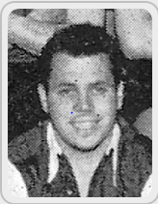
happened, although this time we were only three points distant of Ruislip Manor.

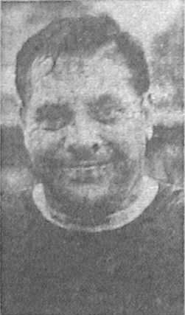
Despite this, he realised he couldn’t do all the jobs at the club on his own and appointed Peter Kenchington (pictured here on two occasions before he joined the club), a former Wimbledon forward, as a Player Manager. He had in fact played once for us as a guest back in the 1965/66 season. He was the archetypal Centre-forward coming through Wandsworth Schools and spent five years at Wimbledon before also playing for Carshalton Athletic. Regrettably, he would only make a further nine appearances here before handing the reins back to Christie again!

The 1972/73 campaign was therefore similarly unsuccessful, although stalwarts remained like Colin Bell, Terry Self, Eric Norman, Alan “Tommy” Thompson and Graham Hemphrey and they were joined by new players, like a promising young defender from Tooting & Mitcham by the name of Alan Webb and exciting striker Paddy Long.

By season’s end Christie had recruited another Sunday League Manager in Peter Spittles and he brought along players like Dave Argent and Brian Kidwell. Most famously, or should I say infamously, he also brought along Steve Whittamore who became a Private Detective in later years and was implicated in the News of the World Hacking scandals in recent years. He would be found guilty of the charge of providing Government Information to journalists in 2004, receiving a two year conditional discharge. Apparently he was once asked to do an address and vehicle registration check on Liz Hurley and Hugh Grant and described his role looking back as “Oliver to the Press’s Fagin”!!

Spittles took charge of our final days in the Athenian League but change was about to happen in the summer of 1973, and in a big way!

How we stand – Locally and Nationally – inc Sat 05/01/19
Here is the latest update on where we all stand.

To summarise for new readers, there are 28 promotion places currently available at Step Six, with 358 teams battling away for those spots. The Champions of each League are guaranteed a promotion, with the best nine runners-up also going up. This number looks as though it will rise by three due to no likely promotions from the South West Peninsula League and the now confirmed folding of Isthmian League Thamesmead Town, but this could yet increase further. For now we’ll continue to look at the 28 and anything else will be a bonus!

In our previous update, we were listed as 89th Nationally but since then we have drawn with Bedfont & Feltham, and beaten Eversley & California and Cove and now sit in 78th place.

Below is our current League table sorted by points per game, while across the page we have the overall top ten and most importantly the 28 clubs who would go up if the season ended right now.

Frimley Green, currently holding the runners-up spot in our League on points per game have the 13th best record of the 19 second placed teams. Our league is so competitive right now that it may well prove to be just the Champions that go up, but I’ll keep updating the position here while we remain involved.

Combined Counties League Division One Table – by PPG
 | Pld | W | D | L | Pts | GD | PPG | Pos
Bedfont & Feltham | 19 | 14 | 4 | 1 | 46 | 44 | 2.42 | 2
Frimley Green | 21 | 14 | 5 | 2 | 47 | 16 | 2.24 | 1
Farnham Town | 17 | 11 | 4 | 2 | 37 | 29 | 2.18 | 5
Sheerwater | 20 | 12 | 4 | 4 | 40 | 18 | 2.00 | 4
Epsom & Ewell | 21 | 13 | 2 | 6 | 41 | 16 | 1.95 | 3
Tooting Bec | 20 | 11 | 4 | 5 | 37 | 18 | 1.85 | 6
Sandhurst Town | 18 | 10 | 3 | 5 | 33 | 1 | 1.83 | 9
Ash United | 21 | 10 | 4 | 7 | 34 | 9 | 1.62 | 7
Dorking Wanderers Res | 23 | 10 | 4 | 9 | 34 | 1 | 1.48 | 8
Chessington & Hook Utd | 19 | 8 | 3 | 8 | 27 | -2 | 1.42 | 11
British Airways | 20 | 8 | 4 | 8 | 28 | 0 | 1.40 | 10
Godalming Town | 19 | 6 | 3 | 10 | 21 | -11 | 1.11 | 12
Bagshot | 23 | 6 | 3 | 14 | 21 | -41 | 0.91 | 13
Eversley & California | 18 | 5 | 1 | 12 | 16 | -11 | 0.89 | 14
Kensington Borough | 20 | 3 | 4 | 13 | 13 | -29 | 0.65 | 15
FC Deportivo Galicia | 19 | 3 | 3 | 13 | 12 | -10 | 0.63 | 16
Fleet Spurs | 20 | 4 | 0 | 16 | 12 | -25 | 0.60 | 17
Cove | 18 | 2 | 1 | 15 | 7 | -23 | 0.39 | 18

Step Six Table – by PPG – Top 10
 | Which League? | Pld | Pts | GD | PPG | Current Pos.
Harefield United | SSML | 20 | 56 | 52 | 2.80 | 1
Easington Sports | HellW | 12 | 33 | 49 | 2.75 | 1
Cheltenham Saracens | HellW | 11 | 30 | 42 | 2.73 | 2
AFC Stoneham | Wess | 19 | 51 | 55 | 2.68 | 1
Cheddar | Western | 19 | 50 | 42 | 2.63 | 2
Selston | E.Mids | 22 | 57 | 54 | 2.59 | 2
Amesbury Town | Wess | 20 | 51 | 39 | 2.55 | 2
Tividale | W.Mids | 26 | 65 | 82 | 2.50 | 1
Billingham Town | Northern | 24 | 60 | 48 | 2.50 | 1
Tavistock | SWP | 20 | 50 | 36 | 2.50 | 2
Epsom & Ewell | We are 78th | 21 | 41 | +16 | 1.95 | 3

Step Six Table – The 28 Promoted Clubs if the season ended today
The 19 Champions – Based on current PPG
 | Which League? | Pld | Pts | GD | PPG | Current Pos.
Harefield United | SSML | 20 | 56 | 52 | 2.80 | 1
Easington Sports | HellW | 12 | 33 | 49 | 2.75 | 1
AFC Stoneham | Wess | 19 | 51 | 55 | 2.68 | 1
Cheddar | Western | 19 | 50 | 42 | 2.63 | 2
Selston | E.Mids | 22 | 57 | 54 | 2.59 | 2
Tividale | W.Mids | 26 | 65 | 82 | 2.50 | 1
Billingham Town | Northern | 24 | 60 | 48 | 2.50 | 1
Tavistock | SWP | 20 | 50 | 36 | 2.50 | 2
Anstey Nomads | UCL | 19 | 47 | 51 | 2.47 | 2
Racing Club Warwick | Midland | 19 | 47 | 41 | 2.47 | 3
Steyning Town | SComb | 19 | 47 | 31 | 2.47 | 1
Longridge Town | NWCN | 23 | 56 | 57 | 2.43 | 1
Burnham | HellE | 14 | 34 | 32 | 2.43 | 1
Bedfont & Feltham | CCL | 19 | 46 | 44 | 2.42 | 2
May & Baker Eastbrook | EastS | 18 | 43 | 25 | 2.39 | 5
Harleston Town | EastN | 24 | 56 | 41 | 2.33 | 1
Welling Town | SCEFL | 22 | 51 | 29 | 2.32 | 1
Rylands | NWCS | 22 | 50 | 55 | 2.27 | 1
Campion | NCEL | 21 | 47 | 27 | 2.24 | 1
The 9 Best Runners-Up
Cheltenham Saracens | HellW | 11 | 30 | 42 | 2.73 | 2
Amesbury Town | Wess | 20 | 51 | 39 | 2.55 | 2
Newark Flowserve | E.Mids | 23 | 57 | 69 | 2.48 | 1
Lutterworth Town | UCL | 21 | 51 | 67 | 2.43 | 1
Alfold | SComb | 17 | 41 | 35 | 2.41 | 3
Heather St Johns | Midland | 22 | 53 | 64 | 2.41 | 1
Plymouth Argyle Reserves | SWP | 25 | 59 | 73 | 2.36 | 1
Broadfields United | SSML | 20 | 47 | 23 | 2.35 | 2
Keynsham Town | Western | 23 | 53 | 41 | 2.30 | 1

Player Sponsorship
Here is the latest list for 2018/19, with new photos showing all of our players and Management that are available for sponsorship.

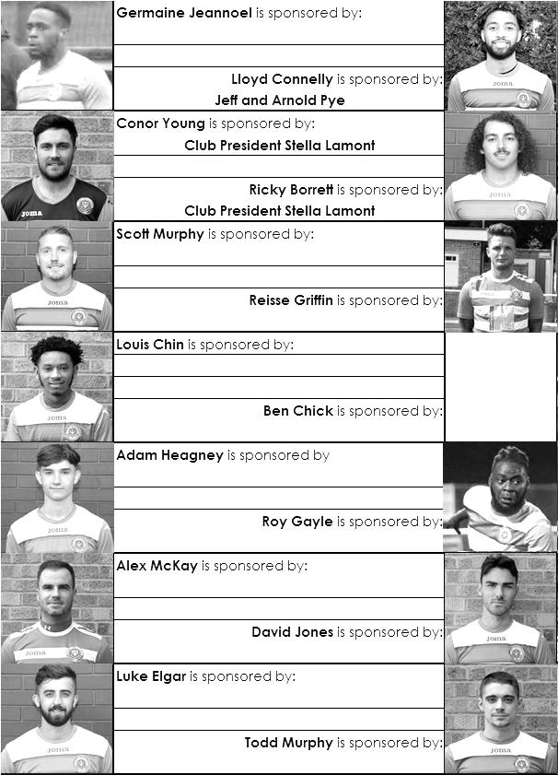

Sponsorship costs just £40 and it is easy to do. Just select a player who has not been previously sponsored and let a Committee Member know that you would like to sponsor them. Beware though. Until we have received the money it is possible for someone to jump in front of you, so don’t delay, sponsor today!
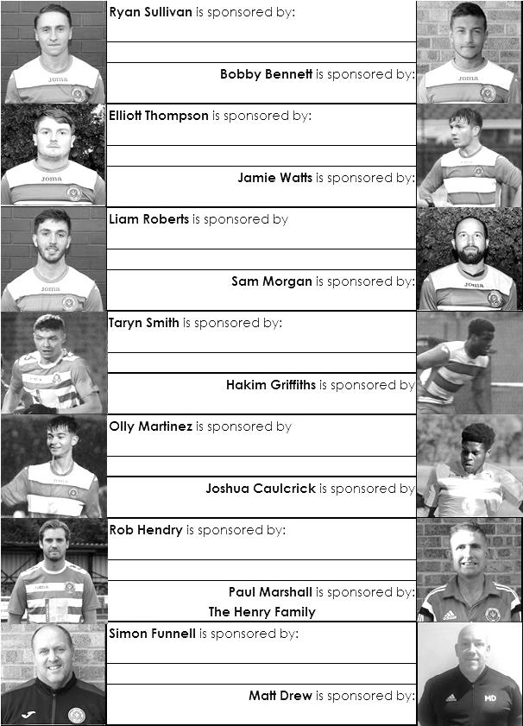

EL Records Premier Challenge Cup
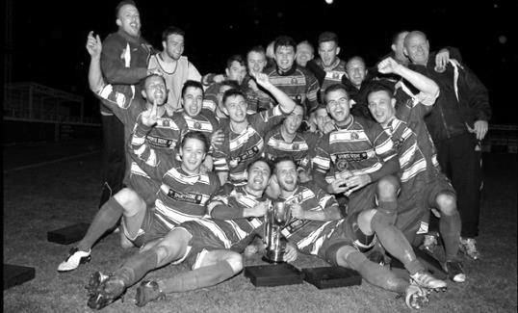
First Round
Camberley Town | 1-3 | Cobham
Horley Town | 0-1 | Chertsey Town
Badshot Lea | 3-1 | Walton & Hersham
FC Deportivo Galicia | 4-1 | Cove
Chessington & Hook United | 2-4 | AFC Hayes
Farnham Town | 1-2 | Southall
Hanworth Villa | 3-1 | Kensington Borough
Second Round
Bedfont & Feltham | 2-0 | Tooting Bec
Sheerwater | 1-0 | Balham
Ash United | 2-3 | Fleet Spurs
Frimley Green | 0-2 | Guildford City
Godalming Town | 2-0 | Dorking Wanderers Reserves
Abbey Rangers | 3-0 | Redhill
FC Deportivo Galicia | 5-0 | AC London
Cobham | 0-3 | AFC Hayes
Abandoned after 88 minutes due to serious player injury - Match awarded to AFC Hayes
CB Hounslow United | 4-1 | Badshot Lea
Hanworth Villa | 2-1 | Sandhurst Town
Epsom & Ewell | 1-0 | Bagshot
Sutton Common Rovers | 4-2 | Southall
Chertsey Town | 3-2 | British Airways
Eversley & California | 1-5 | Knaphill
Banstead Athletic | 4-3 | Colliers Wood United
Spelthorne Sports | 2-1 | Raynes Park Vale
Third Round
FC Deportivo Galicia | 16/1 | Sutton Common Rovers
AFC Hayes | 15/1 | Bedfont & Feltham
Epsom & Ewell | 12/2 | Godalming Town
Sheerwater | 15/1 | Banstead Athletic
Guildford City | 16/1 | CB Hounslow United
Spelthorne Sports | 15/1 | Hanworth Villa
Knaphill | 15/1 | Fleet Spurs
Chertsey Town | 15/1 | Abbey Rangers

CCL Division One Club Directory
AC LONDON: Telephone: 0208 660 5491 - Colours: Orange/Black/Black
Ground: Whyteleafe FC - 15 Church Road, Whyteleafe. CR3 0AR

ASH UNITED: Telephone: 01252 344264 - Colours: Green with Red Trim/Green/Green
Ground: Shawfields Stadium, Youngs Drive, Shawfields Road, Ash, Aldershot. GU12 6RE

BAGSHOT: Telephone: 01252 623804 - Colours: Yellow/Black/Black
Ground: Fleet Town FC - Calthorpe Park, Crookham Road, Fleet. GU51 5FA

BEDFONT & FELTHAM: Telephone: 0208-890 7264 - Colours: Yellow/Blue/Blue

Ground: The Orchard, Hatton Road, Bedfont. TW14 9QT

BRITISH AIRWAYS: Telephone: 0208-890 7264 - Colours: Sky Blue/Navy Blue/Navy Blue
Ground: Bedfont & Feltham FC - The Orchard, Hatton Road, Bedfont. TW14 9QT

CHESSINGTON & HOOK UNITED: Telephone: 01372-602263 Colours: All Blue
Ground: Chalky Lane, Chessington. KT9 2NF

COVE: Telephone: 01252 543615 Colours: Yellow/Black/Black
Ground: Oak Farm, Squirrel Lane, Cove GU14 8PB

DORKING WANDERERS RES Telephone: 01306 400151 - Colours: Red & White Stripes/ Blue/ Red
Ground: Meadowbank Stadium, Mill Lane, Dorking. RH4 1DX

EPSOM & EWELL Telephone: 01737-553250 - Colours: Royal Blue & White Hoops/Royal Blue/Royal Blue - Ground: Chipstead FC, High Road, Chipstead. CR5 3SF

EVERSLEY & CALIFORNIA Telephone: 0118 973 2400 - Colours: - White & Royal Blue Hoops /Royal Blue/ Royal Blue - Ground: Fox Lane, off Reading Road, Eversley. RG27 0NS

FARNHAM TOWN Telephone: 01252 715305 - Colours: - Claret & Sky Blue /White/ Claret & Blue
Ground: Memorial Ground, Babbs Mead, West Street, Farnham. GU9 7DY

FC DEPORTIVO GALICIA Telephone: 0208 831 9067 - Colours: Royal Blue/Royal Blue/White
Ground: Bedfont Sports FC - Bedfont Sports Club, Hatton Road, Bedfont. TW14 9JR

FLEET SPURS Telephone: 01252 662810 - Colours: Dark Blue with Red Trim/Dark Blue/Dark Blue
Ground: Kennels Lane Farnborough. GU14 0ST

FRIMLEY GREEN Telephone: 01252 835089 - Colours: All Blue
Ground: Frimley Green Recreation Ground, Frimley Green Road, Frimley. GU16 6JY

GODALMING TOWN Telephone: 01483 417520 - Colours: Yellow/Green/Yellow
Ground: Wey Court, Meadrow, Godalming. GU7 3JE

KENSINGTON BOROUGH Telephone: 01372 360151 - Colours: All Blue
Ground: Leatherhead FC – Fetcham Grove, Guildford Road, Leatherhead. KT22 9AS

SANDHURST TOWN Telephone: 01252 878768 - Colours: Red & Black Stripes/Black/Black
Ground: Bottom Meadow, Sandhurst Memorial Park, Yorktown Road, Sandhurst. GU47 9BJ

SHEERWATER Telephone: 01483 772470 - Colours: Royal Blue & White/Royal Blue/Royal Blue
Ground: Woking FC - Laithwaite Community Stadium, Kingfield, Kingfield Road, Woking. GU22 9AA

TOOTING BEC Telephone: 0208 540 8843 - Colours: Black & White Stripes/White/White & Black
Ground: Raynes Park Vale FC – Prince George’s Playing Fields, Grand Drive, Raynes Park. SW20 9DZ

Match and Ball Sponsorships – 2018/19
Opponent | Date | Match Sponsor | Ball Sponsor
Chessington & Hook Utd | 21/08/18 | Club President - Stella Lamont
Beckenham Town (FAC) | 28/08/18 | Building Shop Ltd
Cove | 08/09/18 | EEFC Management Committee
Tooting Bec | 15/09/18 | Building Shop Ltd
Bagshot (LC) | 25/09/18
Sheerwater | 06/10/18 | Paul Merritt
Knaphill U23  (Surrey Premier Cup) | 23/10/18 | Jack Jarman
Frimley Green | 03/11/18 | Our Chairman’s Grandchildren – George, Joseph, Ezara and Inaya
Sandhurst Town (LD1C) | 06/11/18 | Richard Lambert
Kensington Borough | 17/11/18 | Jeff & Arnold Pye
Dorkinian (SPC) | 20/11/18
Dorking Wanderers Res | 27/11/18
Godalming Town | 01/12/18 | John Bonner
Bedfont & Feltham | 08/12/18
Eversley & California | 29/12/18
Ash United | 12/01/19 | Gary and Gemma Jarman
Bagshot | 19/01/19
Farnham Town | 02/02/19
Godalming Town (LC) | 12/02/19
British Airways | 16/02/19
AC London | 02/03/19
FC Deportivo Galicia | 12/03/19
Fleet Spurs | 06/04/19
Sandhurst Town | 20/04/19 | Club President - Stella Lamont
Match sponsorship costs just £60.00!

Sponsorship includes:

Admission, programmes and hospitality for three people.

A full page advert in the programme and mascot for the day (if required).

If you are interested, just speak to a Committee Member,
or drop me an email at: richard.c.lambert@gmail.com

Combined Counties League Premier Division
Opponents All-time Records
incl Saturday  5th January | P | W | D | L | F | A | PPG | GD | Best  Win | Worst  Loss
AC London | 1 | 1 | 0 | 0 | 6 | 0 | 3.00 | +6 | 6-0 | -
Bagshot | 2 | 2 | 0 | 0 | 4 | 0 | 3.00 | +4 | 3-0 | -
FC Deportivo Galicia | 1 | 1 | 0 | 0 | 3 | 0 | 3.00 | +3 | 3-0 | -
Tooting Bec | 1 | 1 | 0 | 0 | 3 | 1 | 3.00 | +2 | 3-1 | -
Fleet Spurs | 1 | 1 | 0 | 0 | 3 | 2 | 3.00 | +1 | 3-2 | -
Frimley Green | 11 | 9 | 1 | 1 | 35 | 5 | 2.55 | +30 | 7-1 | 0-1
Bedfont & Feltham | 3 | 2 | 1 | 0 | 17 | 7 | 2.33 | +10 | 9-2 | -
Godalming Town | 4 | 3 | 0 | 1 | 7 | 7 | 2.25 | 0 | 3-2 | 0-3
Ash United | 20 | 11 | 3 | 6 | 50 | 32 | 1.80 | +18 | 6-0 | 0-3
Farnham Town | 18 | 9 | 4 | 5 | 31 | 29 | 1.72 | +2 | 3-0 | 1-4
Cove | 36 | 17 | 9 | 10 | 80 | 58 | 1.67 | +22 | 7-0 | 1-6
Chessington & Hook | 30 | 13 | 9 | 8 | 63 | 45 | 1.60 | +18 | 6-0 | 1-3
Sheerwater | 5 | 2 | 2 | 1 | 10 | 5 | 1.60 | +5 | 3-0 | 2-3
Dorking Wanderers Res | 2 | 1 | 0 | 1 | 6 | 5 | 1.50 | +1 | 3-0 | 3-5
Eversley & California | 2 | 1 | 0 | 1 | 2 | 2 | 1.50 | 0 | 1-0 | 1-2
Sandhurst Town | 16 | 7 | 0 | 9 | 28 | 28 | 1.31 | 0 | 4-0 | 1-3
Kensington Borough | 1 | 0 | 1 | 0 | 1 | 1 | 1.00 | 0 | - | -
British Airways | 1 | 0 | 0 | 1 | 2 | 3 | 0.00 | -1 | - | 2-3

Combined Counties League – Division One
Saturday, 12th January 2019 - Kick-off 3.00 p.m.
Epsom and Ewell  (Royal Blue & White hoops) | V |  | Ash United  (All Grey )
Squad | NUMBERS |  | Squad
Conor Young |  |  | Jamie Cunningham
Louis Chin |  |  | Jamie Aslett
Luke Elgar |  |  | Zach Aubrey-Simpson
Reisse Griffin |  |  | Luke Cairns
Lloyd Connelly |  |  | Jake Charlton
Jamie Watts |  |  | Stanley Chilton
David Jones |  |  | Jordan Devanney
Adam Heagney |  |  | Giacomo Di-Lullo
Todd Murphy |  |  | Ethan Dixon
Ryan Sullivan |  |  | Jack Fitzgerald
Liam Roberts |  |  | Connor Hamill
© Scott Murphy |  |  | Neil Hardy
Scott Elgar |  |  | Josh Kipping
Elliott Thompson |  |  | Emeka Nwaubani
Bobby Bennett |  |  | Brad Passfield
Rob Hendry |  |  | Cameron Rowthorn
Roy Gayle |  |  | Stan Staines
Olly Martinez |  |  | James Whitehouse
Germaine Jeannoel |  |  | Kieran Williams
Hakim Griffiths |  |  | Jake Wilson
Joshua Caulcrick
Taryn Smith
Simon Funnell | MANAGER |  | Sam Wilson
Matt Drew | ASST MANAGER
Sam Morgan | COACHES |  | Kieran Evans
Chantelle Farrell | PHYSIO |  | Colin McCormack
REFEREE: J.Wright
ASSISTANTS: M.Stevens, R.Larkin
Today’s match has been sponsored by
long serving supporters Gary and Gemma Jarman

OUR NEXT VISITORS TO HIGH ROAD
Bagshot
Combined Counties League – Division One
Saturday, 19th January 2019 – 3.00 pm

